# 1. Prerequisites:

Connect as system user and Create new tablespace tbs_lab with new datafile db_lab_001.dat:

create tablespace tbs_lab datafile 'db_lab_001.dat' size 5M autoextend ON next 5M MAXSIZE 100M;

Create new user:

create user Saveli identified by plsdonotpwndme default tablespace tbs_lab;

Grant Connect Role and Resource Role:

grant connect to Saveli;

grant resource to Saveli;

grant select on scott.dept to Saveli;

grant select on scott.emp to Saveli;

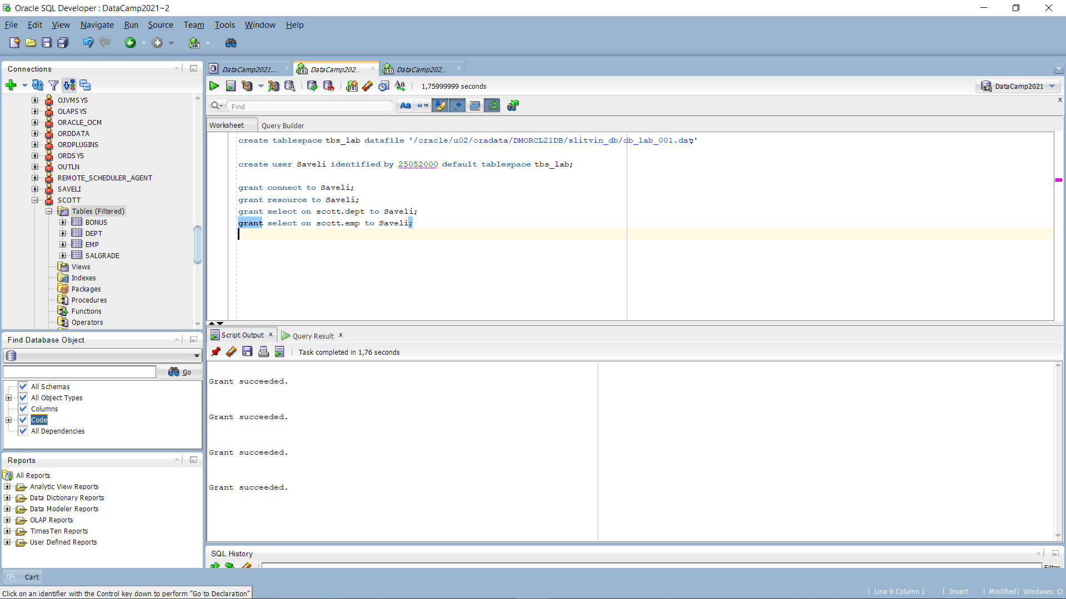

I used web to find scott.dept and scott.emp creation steps. As you can see, at the left side of attached screenshot – Scott user is defined and has 4 tables in our tablespace. All grants were successful, at this way we can enjoy our next task.

Finally I estable new connection via created credentials, and again, at the left side you can see, that there’s only 2 Tables from Scott user granted is available.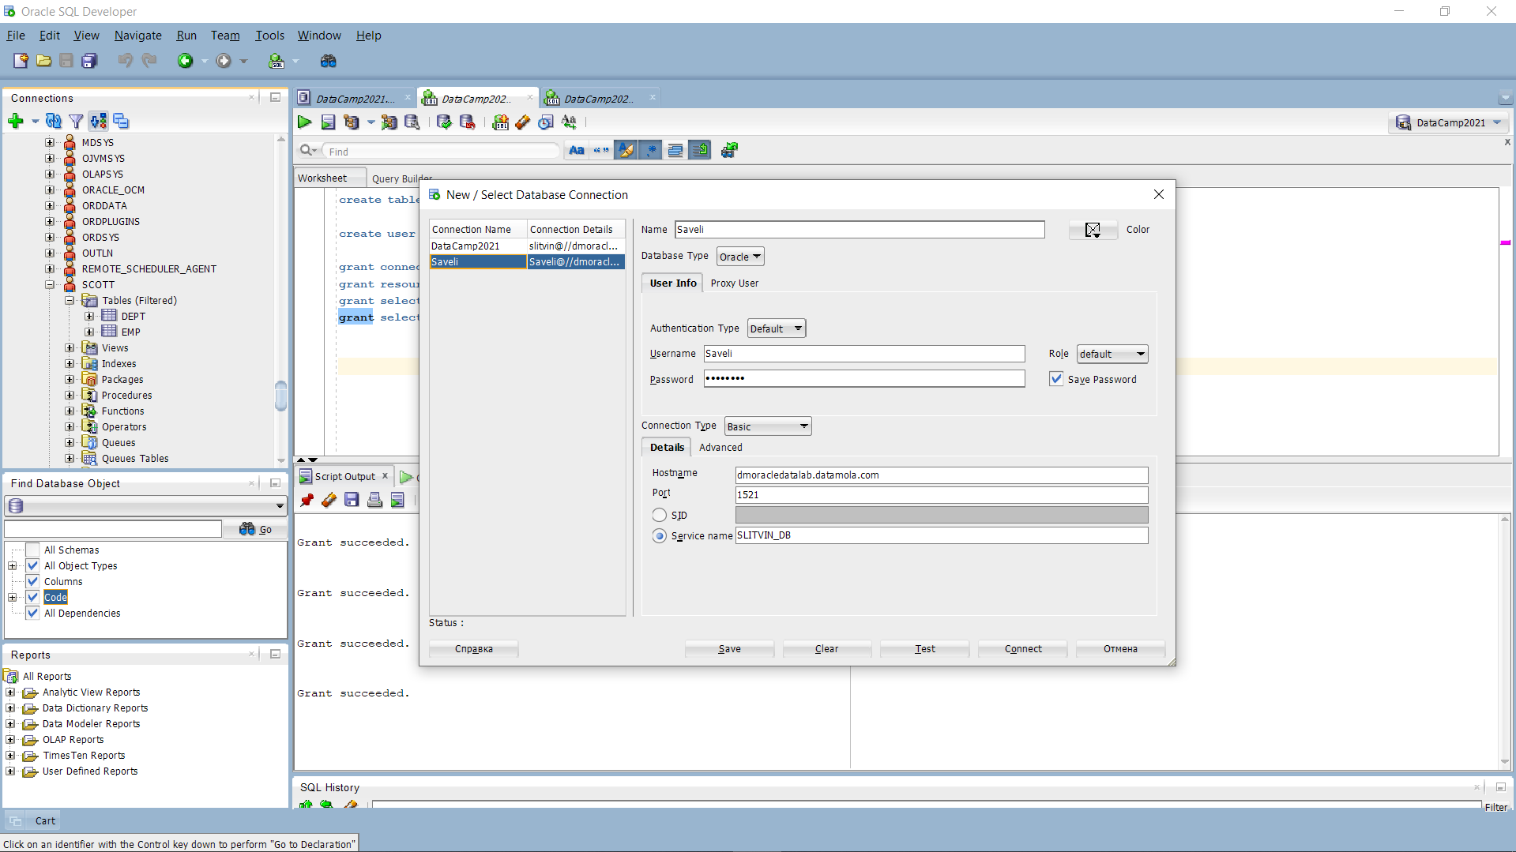

# 2. Heap Organized Tables

## 2.1. Task 1 – Heap Understanding

First output was successful after using command “ALTER USER Saveli quota unlimited on tbs_lab;” in dba account window. Code output until step 4 attached via screenshot.

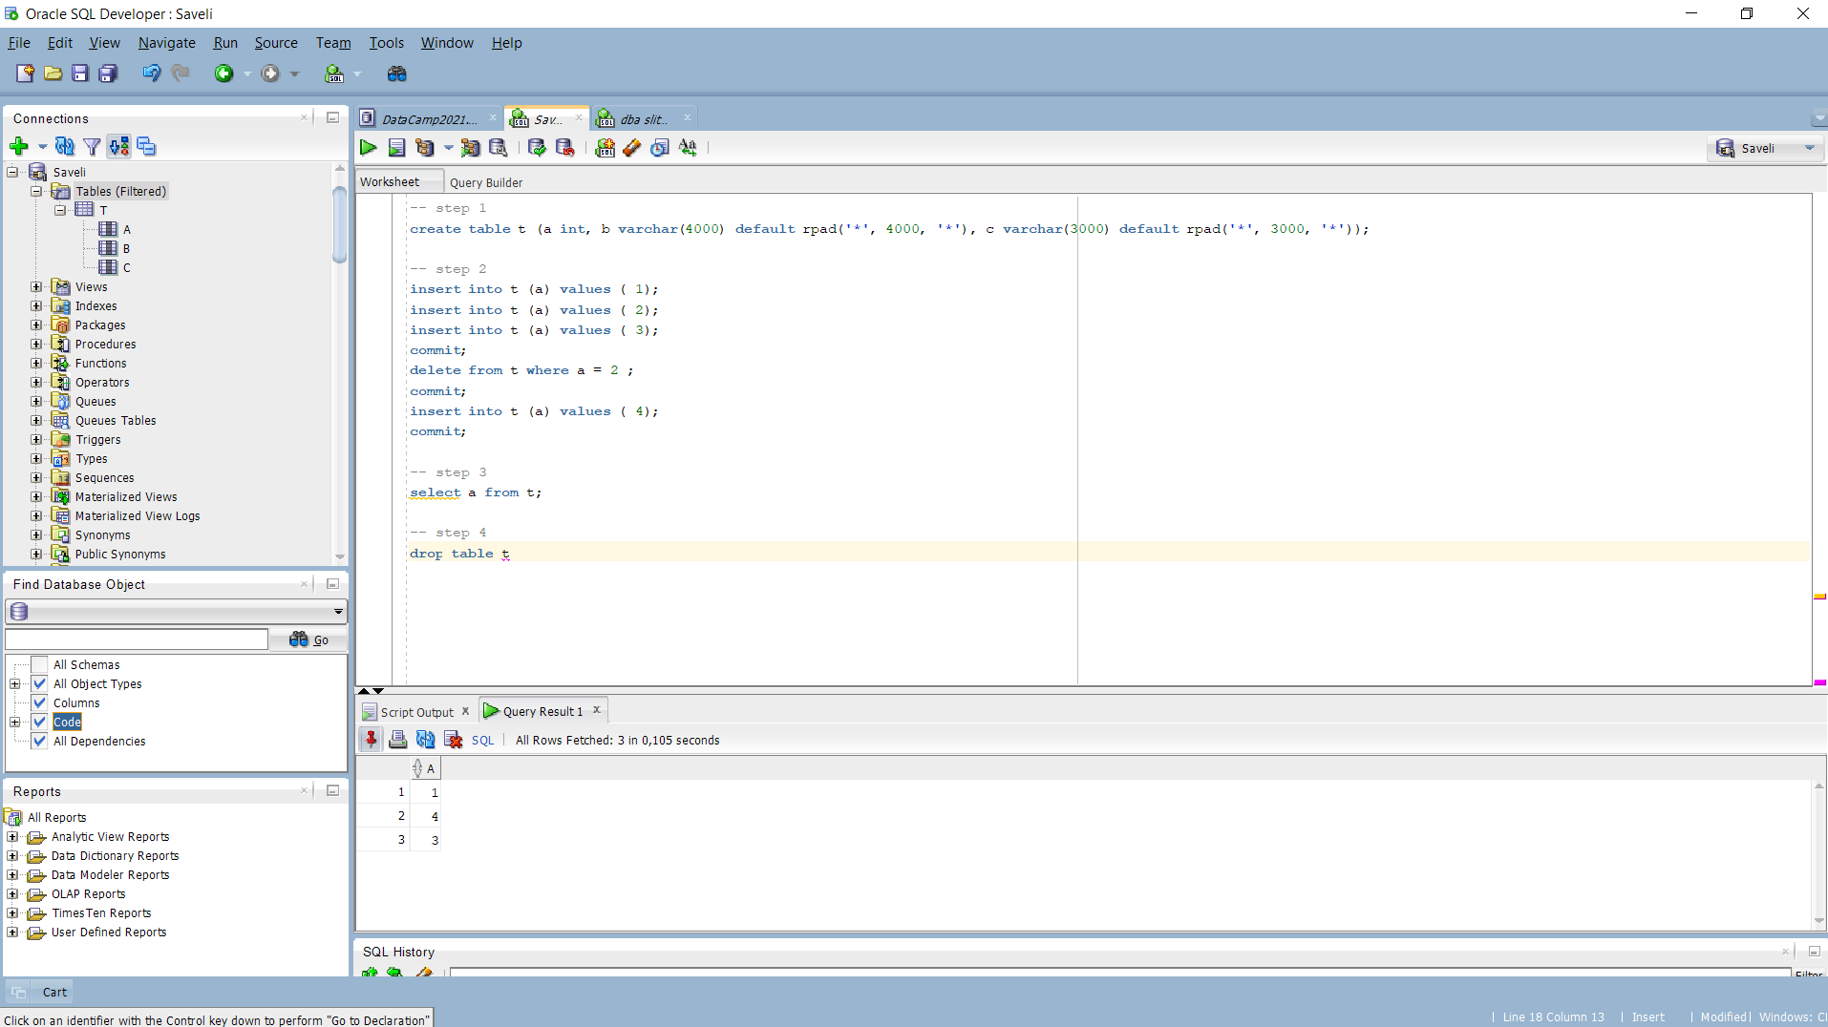

## 2.2. Task 2 – Understanding Low level of data abstraction: Heap Table Segments

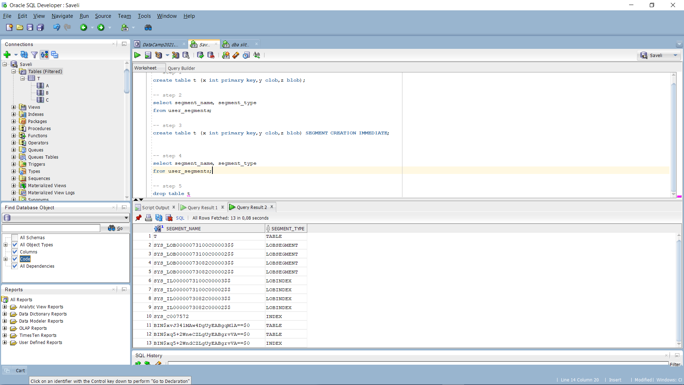

The difference between output till step 3 and in steps 3-4 is that T has been included into the Segmenation block.

To check metadata of our table we’ve using next function SELECT DBMS_METADATA.GET_DDL('TABLE','T') FROM dual

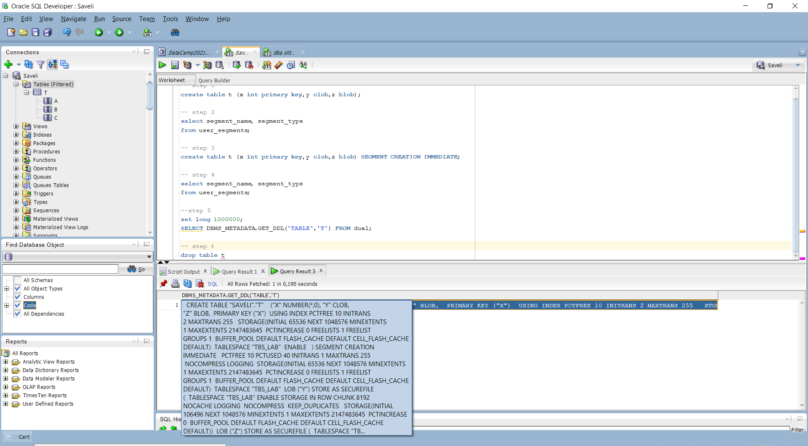

We can assume that our data stored in predefined above tablespace tbs_lab. Also, we’re retrieving our metadata as dictionary in xml.

# 3. Index Organized Tables

Task 3: Compare performance of using IOT tables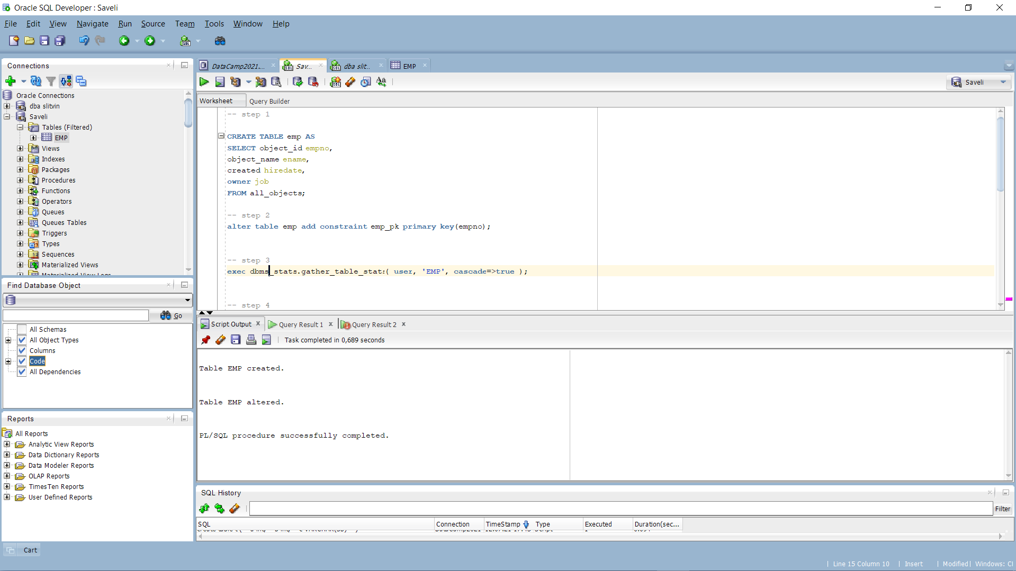

Table is created and primary key is applied. By initiate a second step I’ve got an error ORA-01658, the solution was to init this command from dba connection :

alter database

datafile '/oracle/u02/oradata/DMORCL21DB/slitvin_db/db_lab_001.dat'

AUTOEXTEND ON

MAXSIZE UNLIMITED;

The command increased maximum size of tablespace file created with upper bound of 100mb to unlimited size.

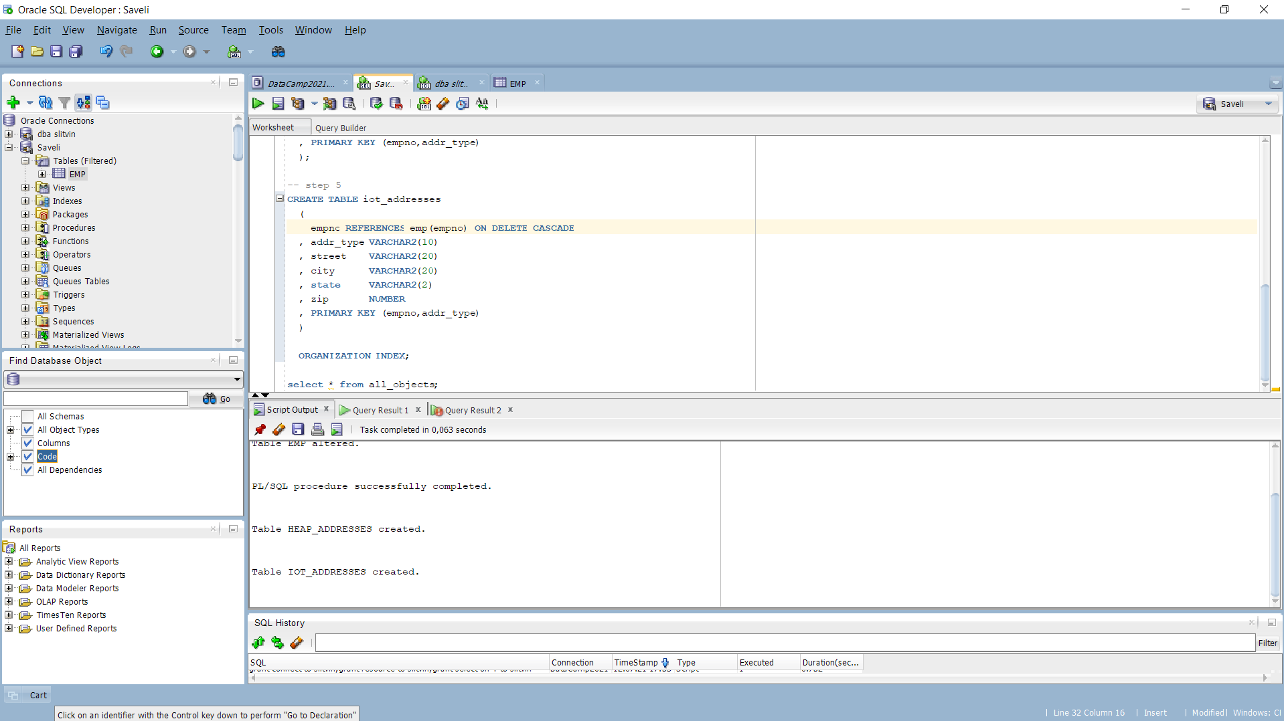

Tables heap_adresses and iot_addresses were created without issues.

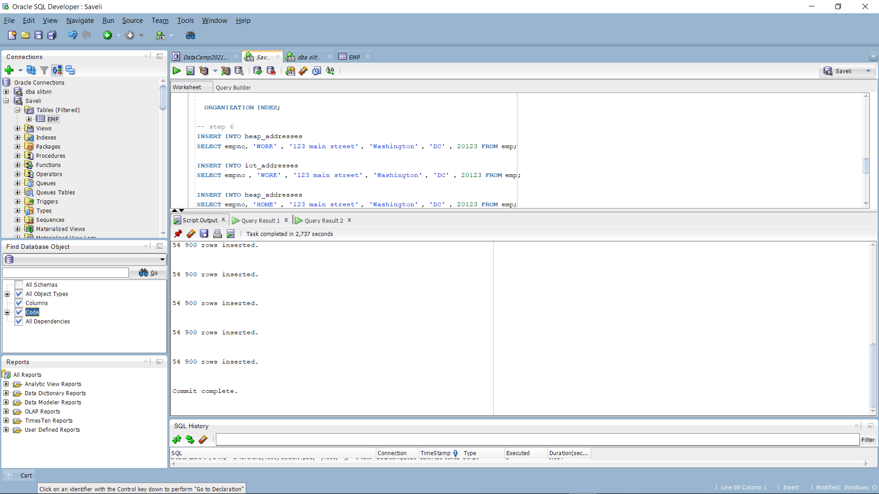

Init was completely done

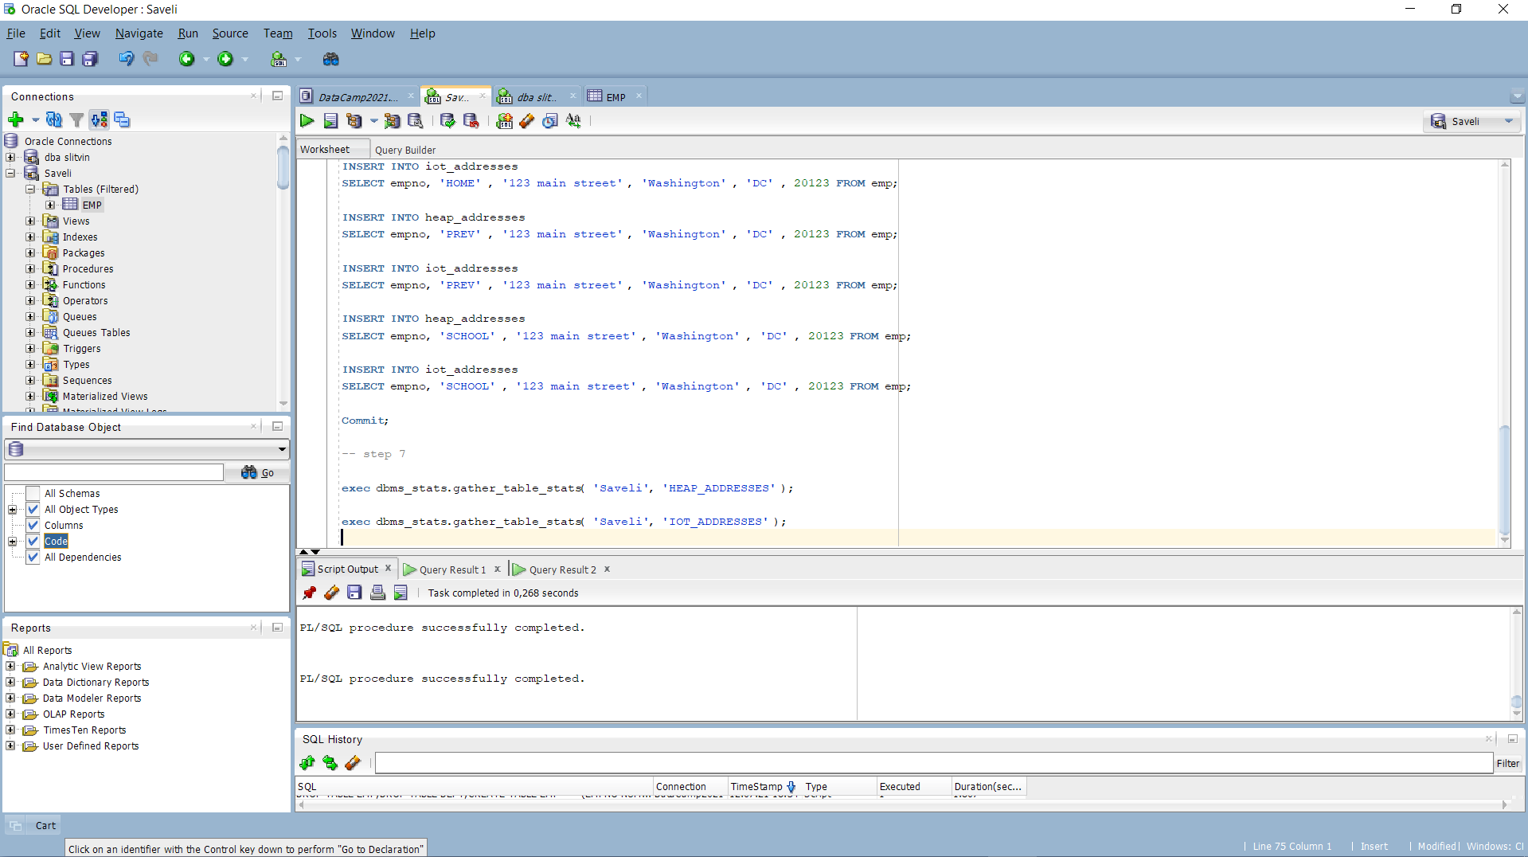

Stats is calculated

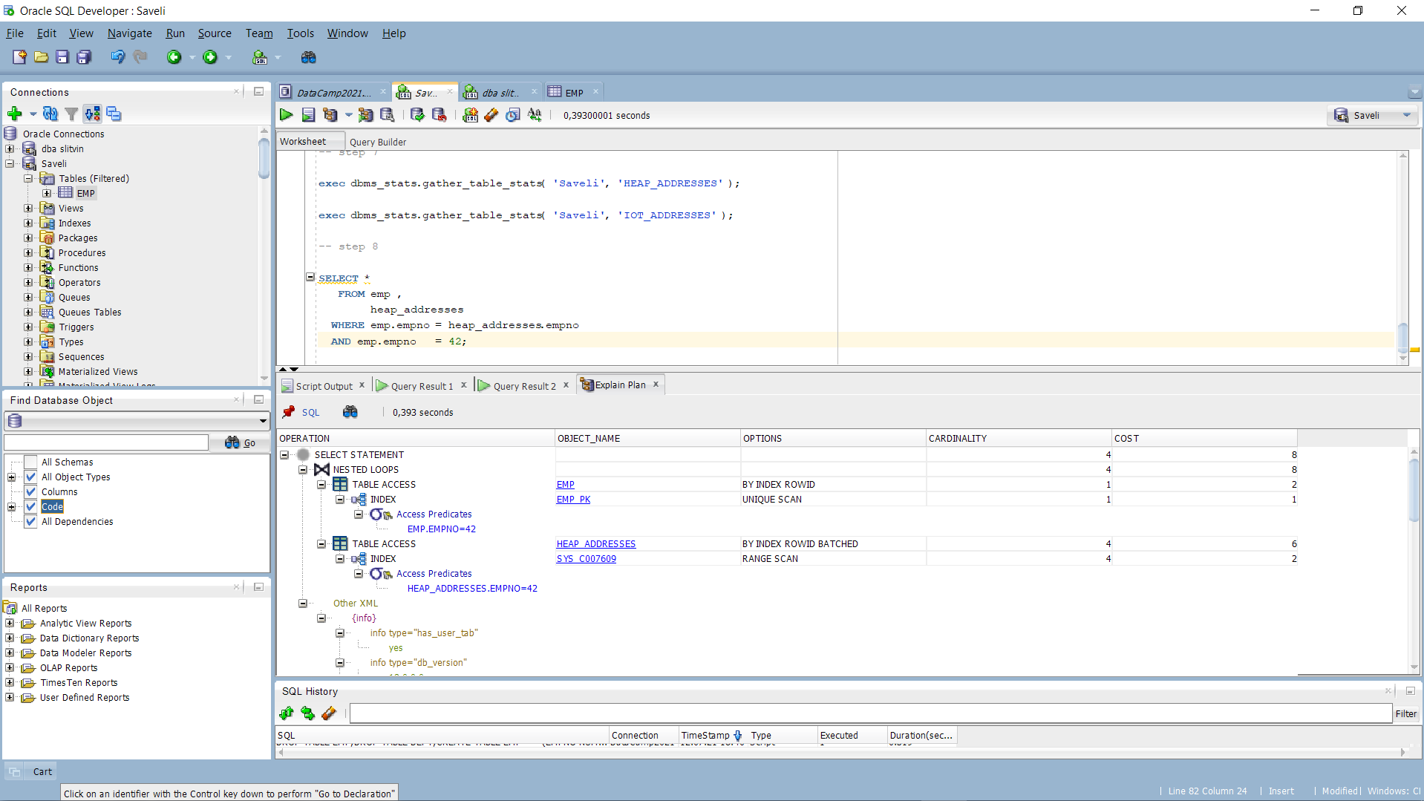

Explain Plan for heap_adresses table

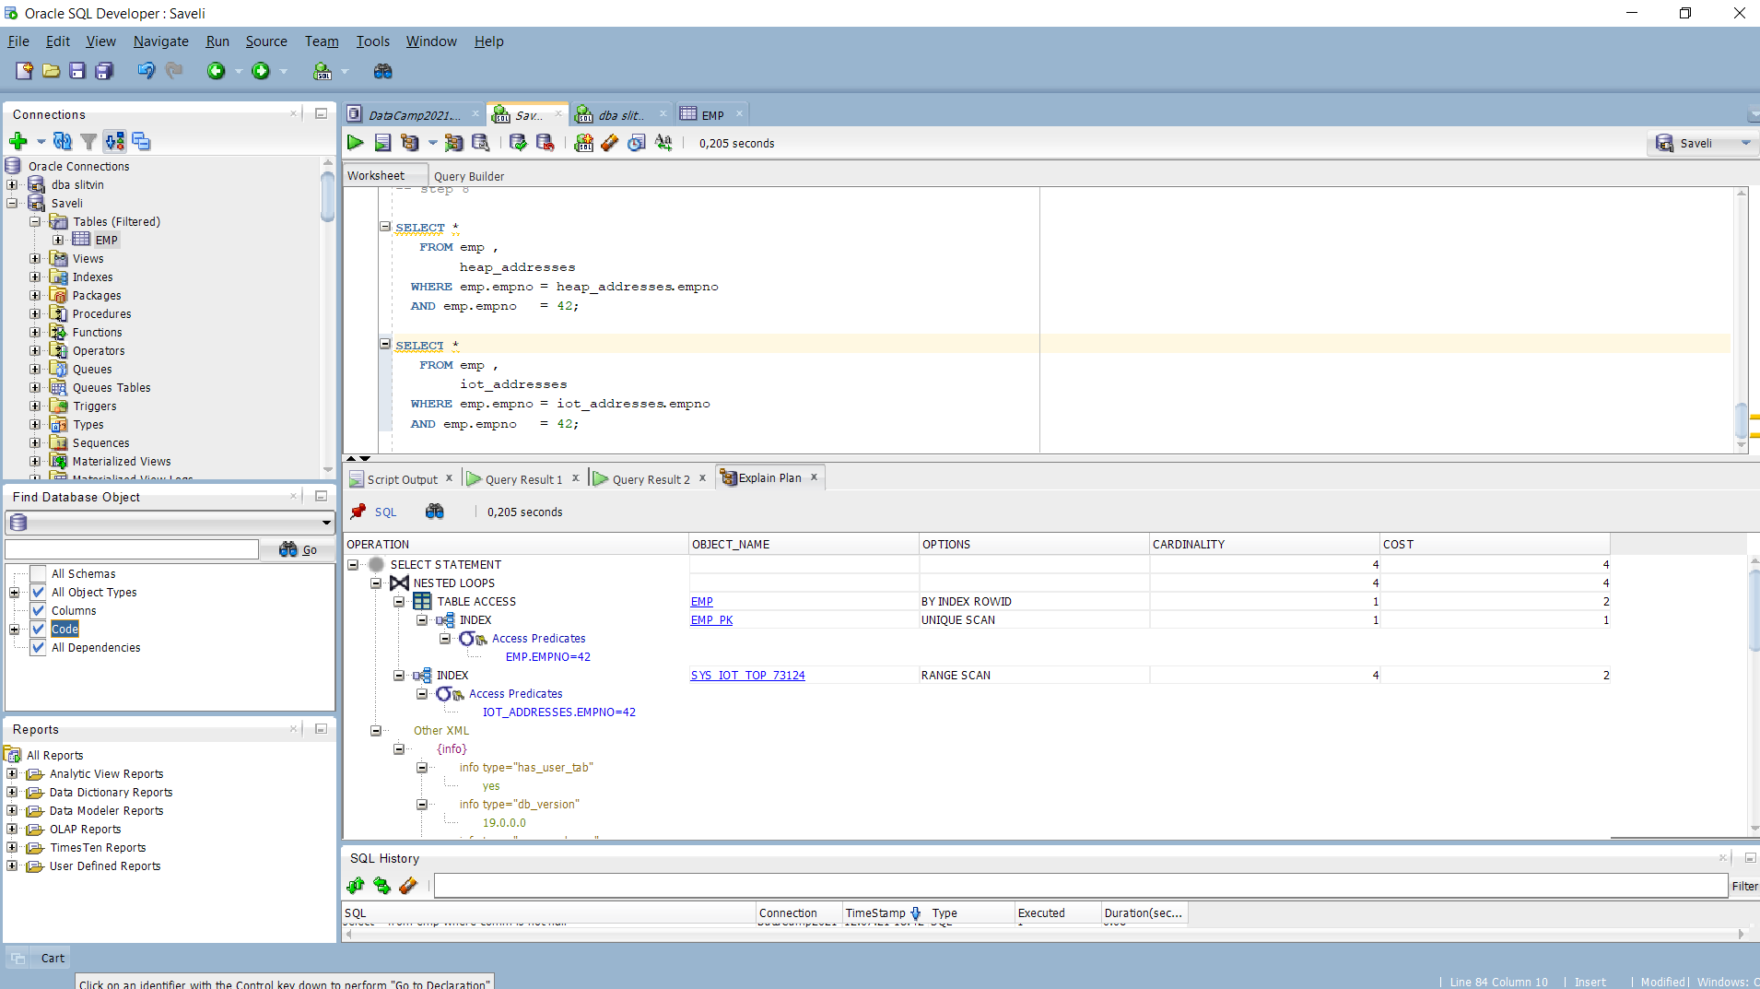

Explain plan for iot_adresses table

Well, we can attempt Attention at Cost-Based-Oriented(COST) column, from which we can assume that iot table is much more faster and cheaper for our sql querry.

It’s because we’ve used index organization table type. The sorting goes trough the primary key, the meaning of accessfull is much more faster.

At this way using an index organization could decrease cost and time to access data inside table and the main plus is that, cause of index and the table are created in the same segment, less storage is needed.

Final step is to drop tables we’ve created before.

Funny, that ‘emp’ table could be dropped only when all other tables with unique or primary keys referenced by foreign keys in another table will be dropped. But it truly fair.

# 4. Index Clustered Tables

## Task 4: Analyses Cluster Storage by Blocks

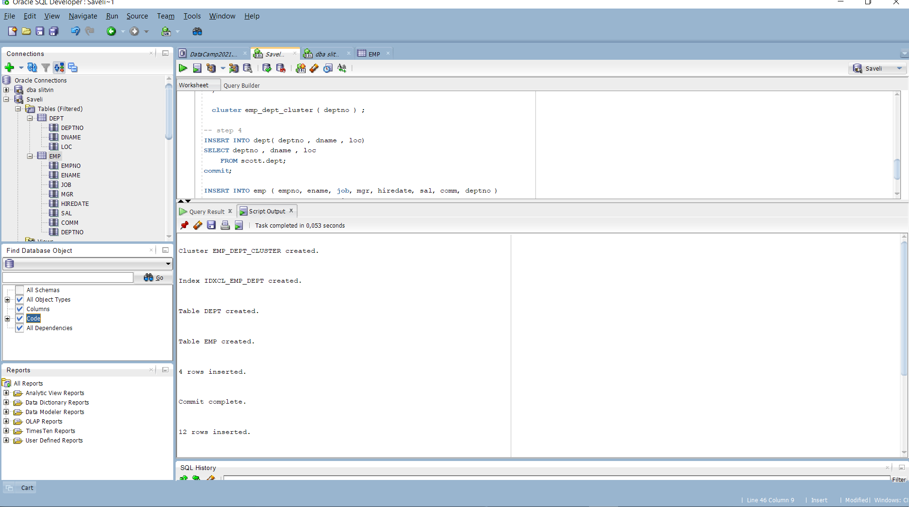

Steps 1-4

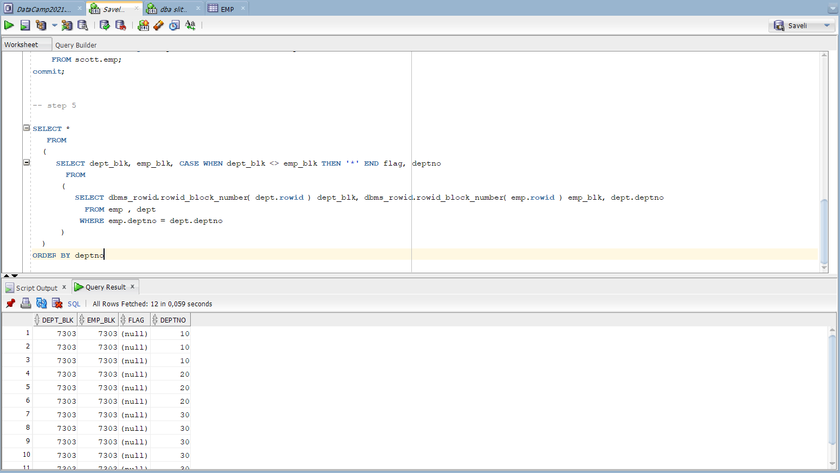

All the data stored in the same block with only dept increasing